YUV Tools

Table of Contents

1. AVCapture app 2

1.1 Overview 2

1.2 Capture NV12 YUV file 2

2. NV12 To YUV420 Tool 5

2.1 Overview 5

2.2 AVCapture and then transform 5

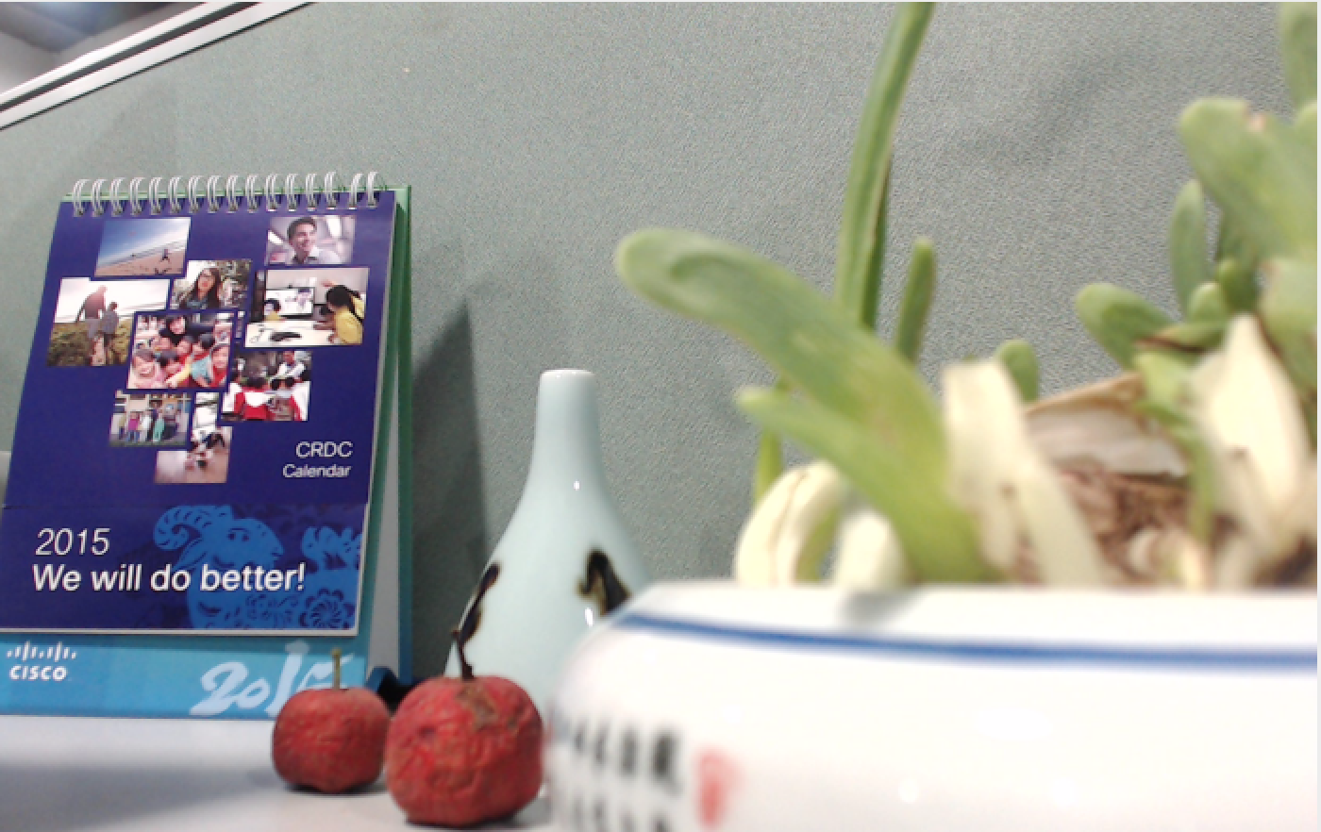

# 1. AVCapture app

## 1.1 Overview

AVCaptureDemo app is used to capture YUV file.

Current implement feature is capture nv12 format yuv file on mac.

You can implement other format by modifying the source code. For source code, please refer to [CiscoInternalGithub](https://sqbu-github.cisco.com/huashi/AVCaptureTool) for more detail.

( <https://sqbu-github.cisco.com/huashi/AVCaptureTool> )

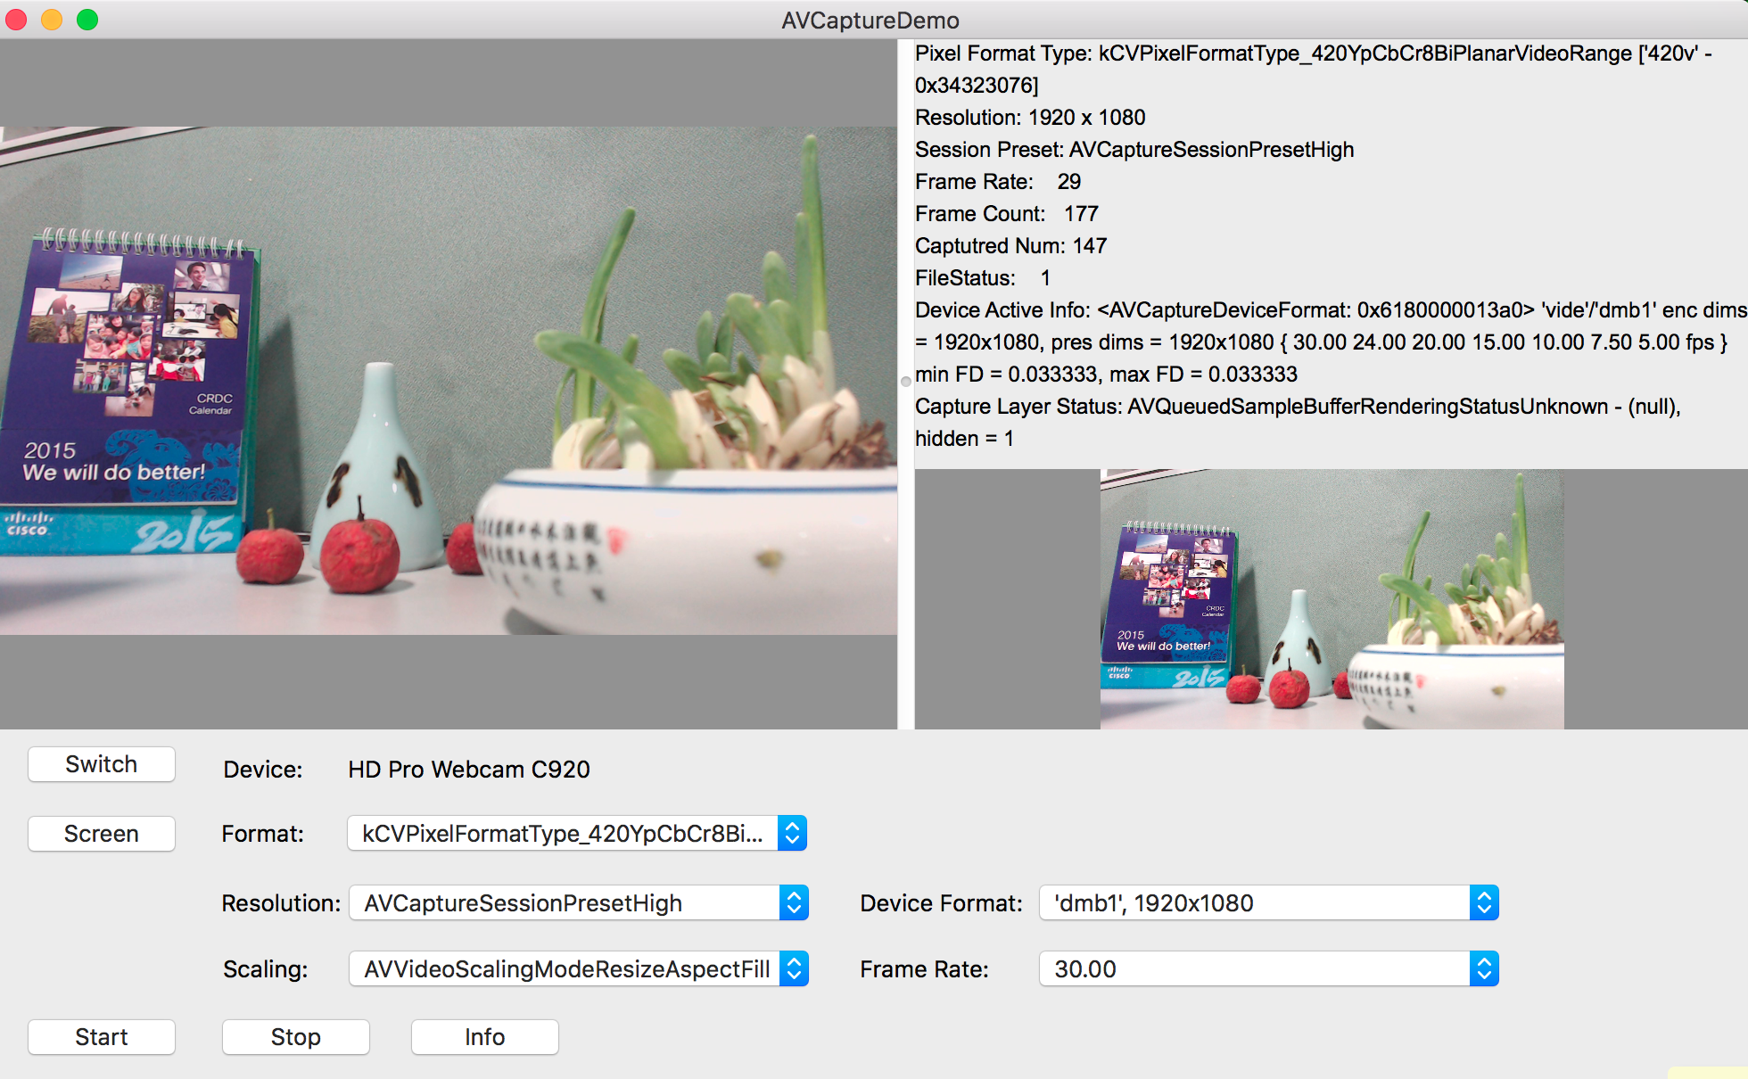

Figure 1.1

## 1.2 Capture NV12 YUV file

Step 1. Refer to Figure 1.2

Select “kCVPixelFormatType_420YpCbCrBiPlannarVideoRange” format;

Step 2. Refer to Figure 1.3

Select device format for capture resolution, “yuvs” “dmb1” etc. has different

output fps due to hard ware capability .

Step 3. Refer to Figure 1.4;

Select output fps;

Step 4. Refer to Figure 1.5;

Click start button to start capture nv12 files;

Clice stop if the capture num is match what you want display as

“Captured Num: xxx”

Note:

* The output nv12 file will be located under~/Desktop with name format like:

“TestYUV_PicWxPicH_nv12.yuv”;

* Please rename this file based on capture content. Other wise, will be overwrite by next time when you capture with the same resolution.

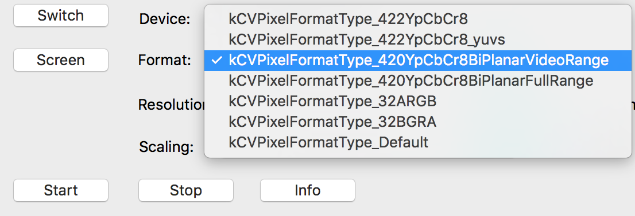

Figure 1.2

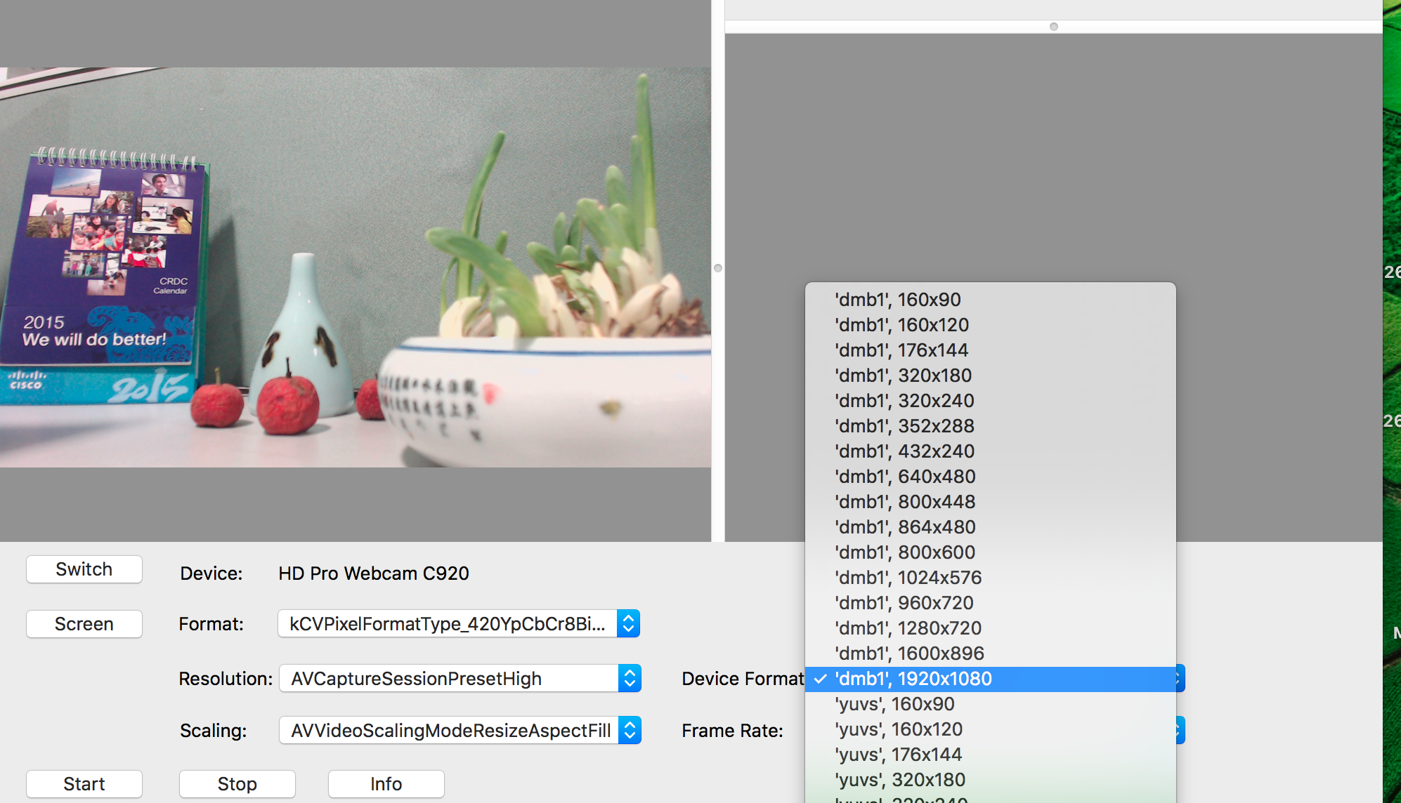

Figure 1.3

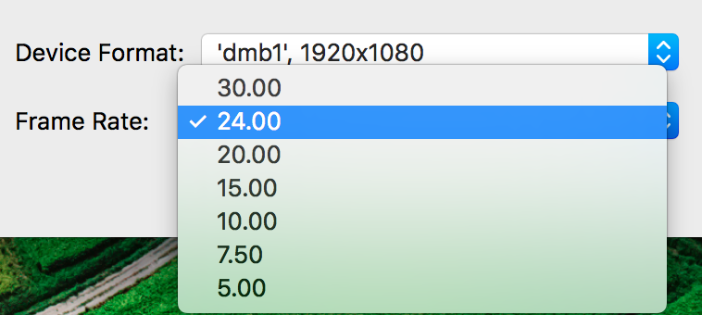

Figure 1.4

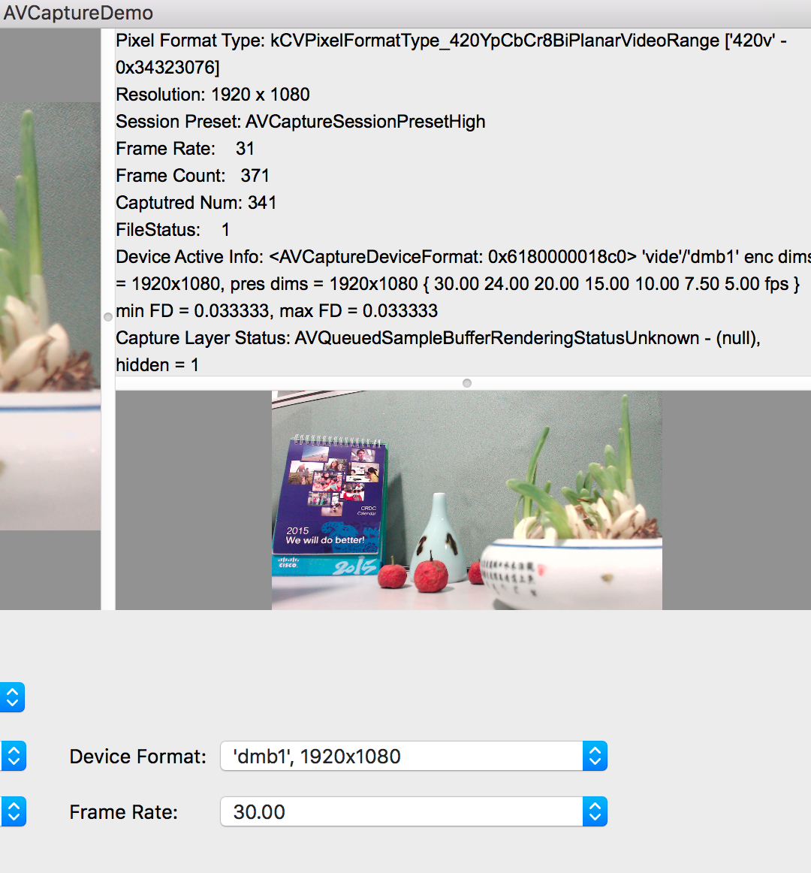

Figure 1.5

# 2. NV12 To YUV420 Tool

## 2.1 Overview

Script *run_NV12ToYUV420.sh*

* Transform nv12 file to YUV420 format.
* Upload to ftp server if using upload or pipeline option
* For how to use, please refer to below link:

<https://sqbu-github.cisco.com/huashi/AVCaptureTool/blob/master/run_NV12ToYUV420.sh>

YUVTool source code:

* Transform raw video data files’ format among rgb/YUV420/NV12 etc.
* NV12 to YUV420 is one of tool’s feature
* You can add/modify feature by changing source code
* More detail, please refer to below link:

<https://sqbu-github.cisco.com/huashi/AVCaptureTool/tree/master/YUVTool>

## 2.2 AVCapture and then transform

As nv12 files captured by AVCaptureDemo app is located under ~/Desktop,

and script’s default nv12 is the same with it.

You can run below command to transform to YUV420 format:

./run_NV12ToYUV420.sh Camera transform //transform only for ~/Desktop/*nv12*.yuv

./run_NV12ToYUV420.sh Camera transform //transform and upload to ftp server